Printing CBM Reports in PeopleSoft Version 9.0 (Tools 8.55)

With the new version of PeopleTools 8.55, it was necessary to revise the reporting process to access a secure Crystal Reports server.

NOTE: REPORTS SHOULD NOT BE RUN IN INTERNET EXPLORER (IE).

To access the CBM Reports list, click Main Menu; then choose Budget – Report.

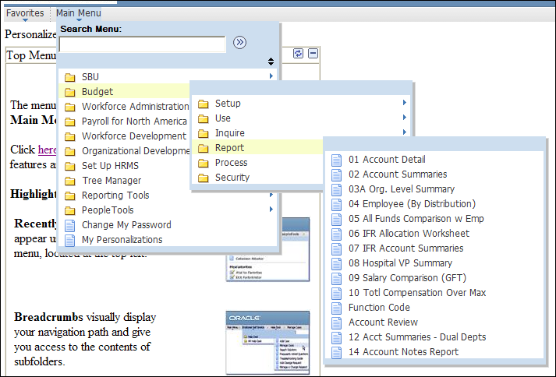

The list of CBM reports (based on your CBM security profile) will be displayed. Click on any report in the list.

An alternate way to access CBM reports is through Favorites. This shows reports you have recently used. Click on the report name link to access a report in the list.

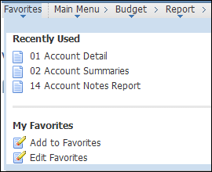
After you choose a report, the Run Control ID Search page will be displayed. In order to print in PeopleSoft, at least one Run Control ID needs to be set up to hold the processing and print parameters.

Notice there are two tabs: Find an Existing Value and Add a New Value.

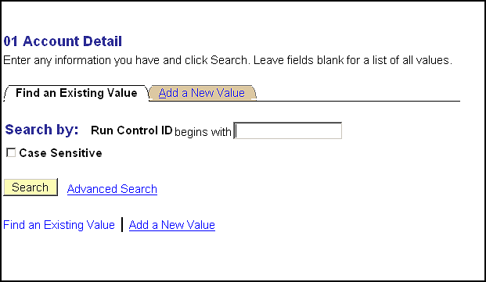

If you have an existing Run Control ID, click on Search in the Find an Existing Value tab. If you have multiple Run Control IDs, a list of your Run Control IDs will be displayed. Click a Run Control ID from the list and the Report page will be displayed.

Note that if you have only one Run Control ID, the Report page (where you input Model, Account, and other report parameters) will be displayed when you click the Search button.

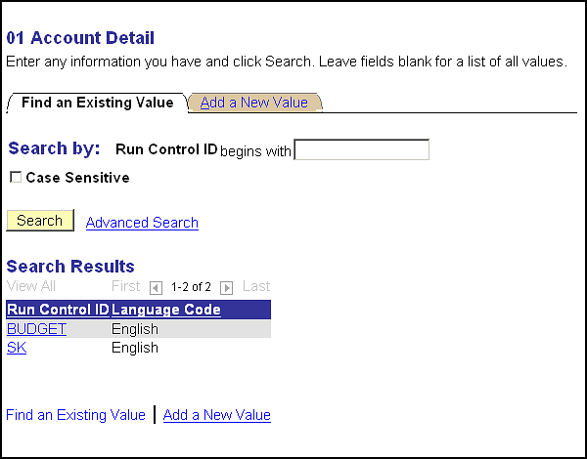

If you do not have an existing Run Control ID, click on the tab Add a New Value. Enter a name for your Run Control ID that is no longer than 13 characters with no spaces. Click the Add button and the Report page will be displayed.

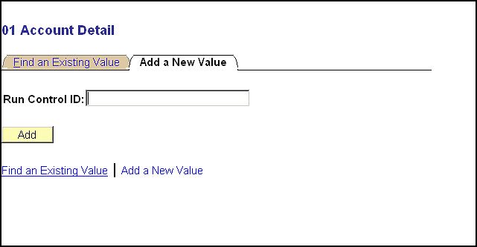

Each CBM report has a page where you input Model, Account, Department, or Fund, and other specific report parameters.

Input the Model and other Parameters for the selected report. Click the Run button.

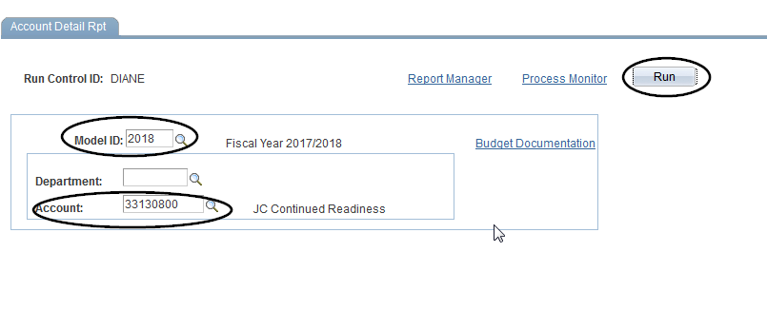

The Process Scheduler Request page will be displayed. This is where you will choose the specific report you want to run and set up the output parameters.

Make sure the Server Name is PSUNX.

Check off the report version you wish to run; i.e. Hospital Account Detail.

Click OK.

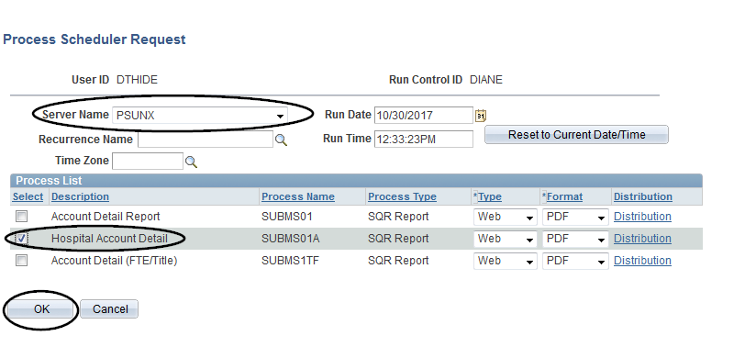

The Report page will again be displayed. Note that it now shows the Process Instance number for your print job under the Run button.

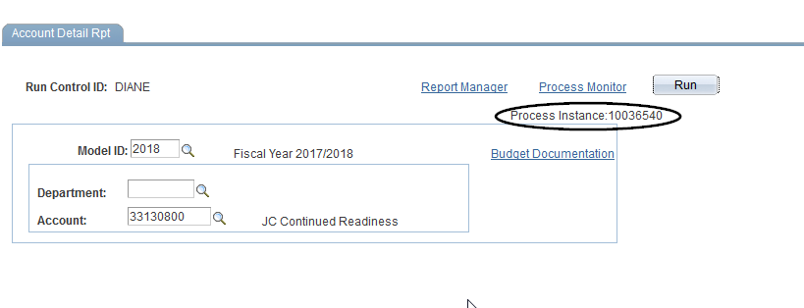
Click on Process Monitor.

The Process List page will be displayed. It shows the reports you have processed with the most recent report listed at the top.

Click the dropdown box to the left of the Refresh button and choose Days.

Make sure that the Type dropdown is blank.

Click the Refresh button to update the Run Status column in the grid.

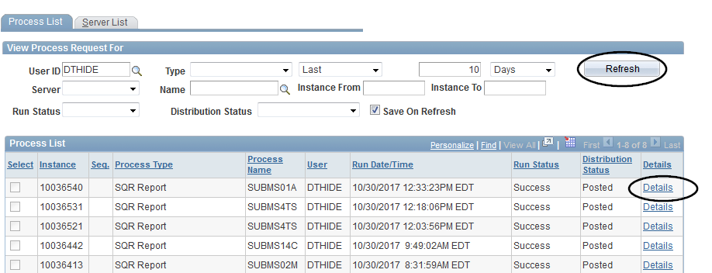

Each print job that you have submitted will show on an individual line that begins with its Process Instance number.

Click the Refresh button until the print job in the grid shows Run Status of Success and Distribution Status of Posted; this means that your print job has completed processing.

When your report shows Run Status of Success and Distribution Status of Posted, click the link to the right of the report that says Details.

The Process Detail page will be displayed.

For all reports except Report 05, click the View Log/Trace link.

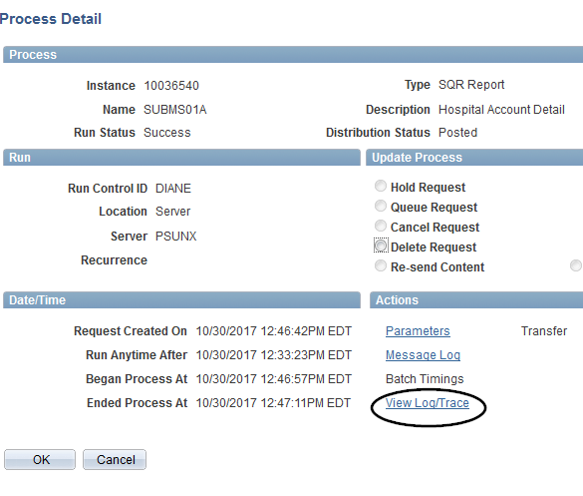

Clicking on the link will open up the View Log/Trace page.

Click on your report listed under the URL Links.

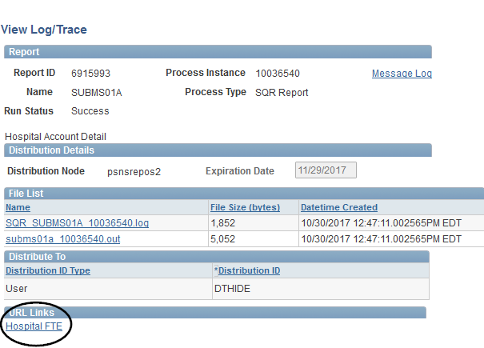

NEW: SECURE CRYSTAL REPORTS SERVER

All reports are accessible via the secure Crystal Reports server. From the Log On screen, make sure the CMS Name is set to CRWPROD:6400. (You should only need to set this up once.)
Input your NETID password and click the Log On button.
(Note if your PeopleSoft USERID and your NETID are different, you will need to update to your NETID as the default will be your PeopleSoft USERID.)

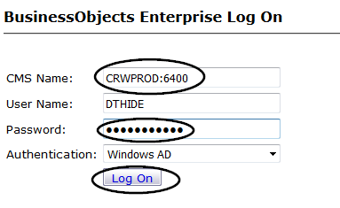

Your report will open in a separate window in Crystal Reports Viewer.

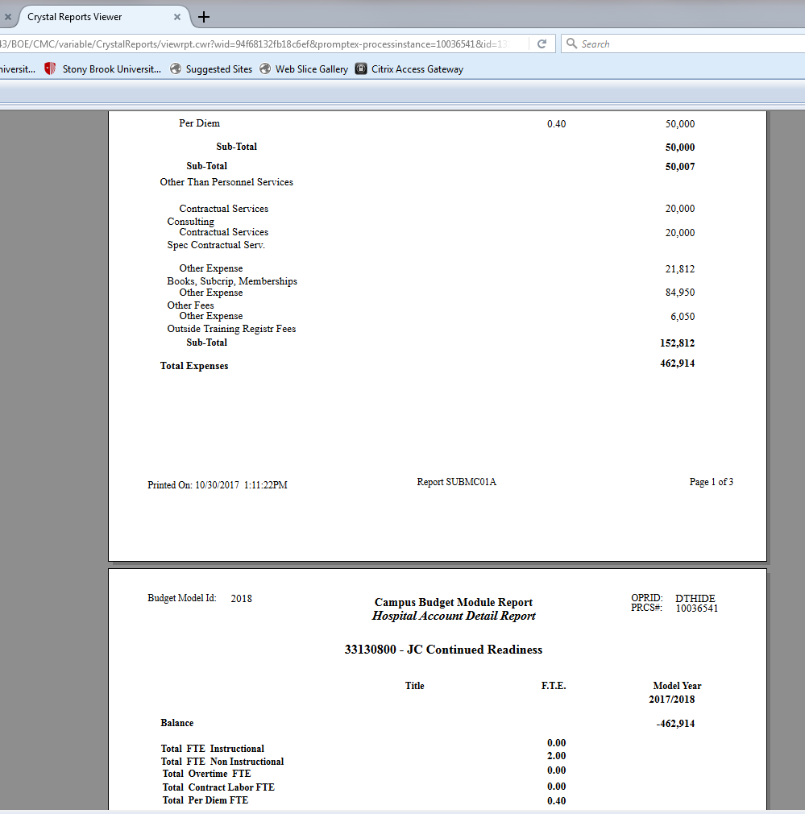

In the upper left area of the Crystal Reports Viewer, you will see this icon:

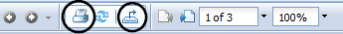

To print your report: Click on the Printer icon.

To download your report to Excel or PDF or Crystal Reports (if you have this software installed on your machine): Click on the Download icon.

In both cases, the Export box will open; click Export to open a file for printing or downloading. Note that even though the report presents as Landscape in Crystal Reports Viewer, you will need to select Landscape when you print from the file you export to.

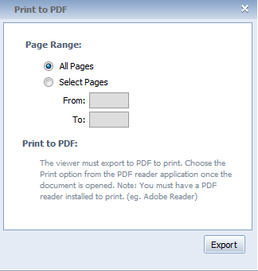

Note: If you have any difficulty exporting your file from the Crystal Reports Viewer, please contact Client Support so they can address the issue which may be related to your computer setup or how Adobe is installed on your machine.

To view Report 05, click on Process Name SUBMR05.

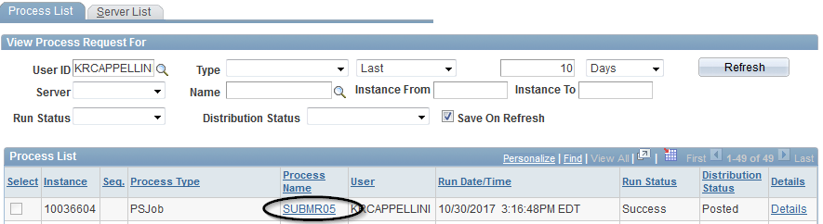

Clicking on the Process Name will open the Process Detail page.

Select the second link on the Process Detail page.

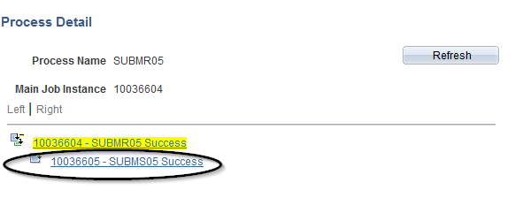

Click on the View Log/Trace link to open the View Log/Trace page.
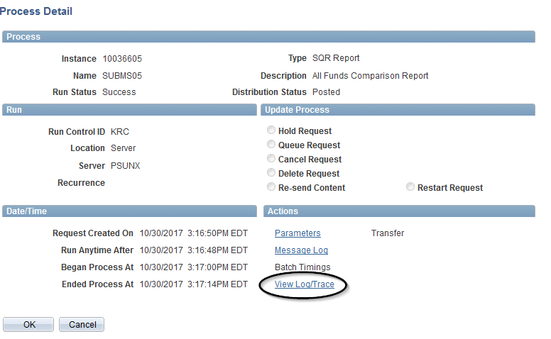

Once the View Log/Trace page is opened, select the second link in the File List.

The second link will have the file extension, indicating the format of the report (i.e. PDF).

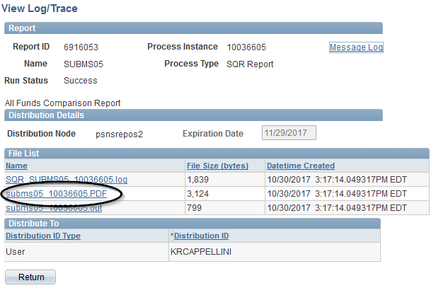

Your report will open in a new window in your browser.

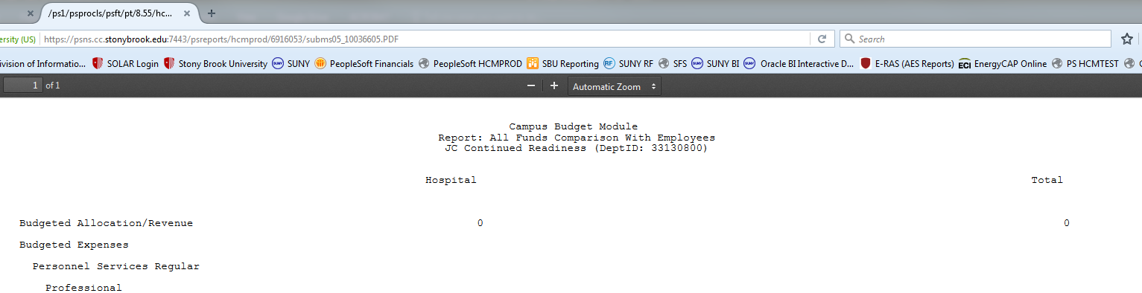

To print your report: select the print icon on the tool bar, or go to File, then Print in the left-hand corner of your screen.

Remember to format your report as Landscape before printing. Even though the report is shown as Landscape in your browser, you will need to specify the orientation in the print properties setting.



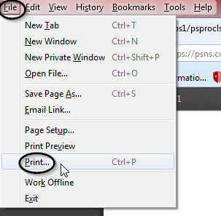

To download your report: select the download icon on the tool bar.



